5E Lesson Plan Template
Teacher
Date | February 10th 2020
Subject area/course/grade level | Language Arts- 3rd grade
Materials | Chromebooks, paper, pencils, adjective sheets
Standards (State and ISTE Standards for Students) | State Standards  L 3.1) Demonstrate command of the conventions of Standard English grammar and usage when writing or speaking.  L3.1g Form and use comparative and superlative adjectives and adverbs, and choose between them depending on what is to be modified.  ISTE Standards  6)Creative Communicator-  b. create original works or responsibly repurpose or remix digital resources into new creations  d. publish or present content that customizes the message and medium for their intended audiences.
Objectives | Students will learn to write adjectives in comparative and superlative form and distinguish between a comparative and superlative adjective.
Differentiation Strategies (How will the lesson address the various learning styles of the students and the needs of those with special needs?) | Students who are visual learners will be able to see examples on the board or on paper  Reading and writing learners will be able to understand comparative and superlative adjectives by reading writing comparative and superlative adjectives. As  Special needs students will have shorten assignments and a peer helper to help assist with activities.

The 5 Es
E | Description | Assessment
Engagement | The teacher will pick a student volunteer to come to the front of the room.  The teacher will ask students to write down words on their personal white boards that describe the student. (funny,tall,girl,hyper)  The teacher will call on students to share their answers and the teacher will write the words on the board.  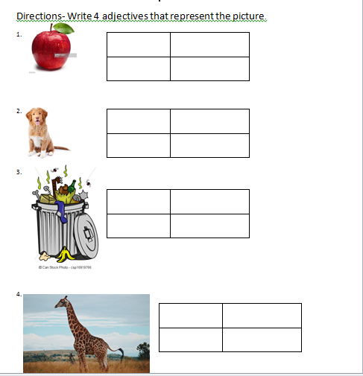  The teacher will pick another student volunteer to come to the front of the room and they will repeat the same process.  The teacher will ask students if the two student volunteers have any differences. ( EJ is taller than James, James is calmer than EJ)  The teacher will call on students and write their answers on the board.  Students will work in pairs to complete the assessment. | The assessment will be used to determine if students can write correct adjectives to describe the noun.
Exploration | The students will work in pairs to answer the comparison questions. ( Who is the strong?, which one is healthy?)  The students will answer the questions on a piece of paper.  After each question the students will pick a different partner to answer another question.  When the students are done with the first four sentences, they will get in groups and answer more comparison questions.  When all the groups are done the teacher will call on a few students to share their answers.  The teacher will write on the board the adjectives that the students will call out. The teacher will place the adjectives into two columns. (comparative and superlative)  The teacher will not label or tell students the reason for the two columns.  Assessment- Students will work together to complete assessment 2. (Look on assessment column for assessment screenshot)  Below- Pair and group worksheet screen shot  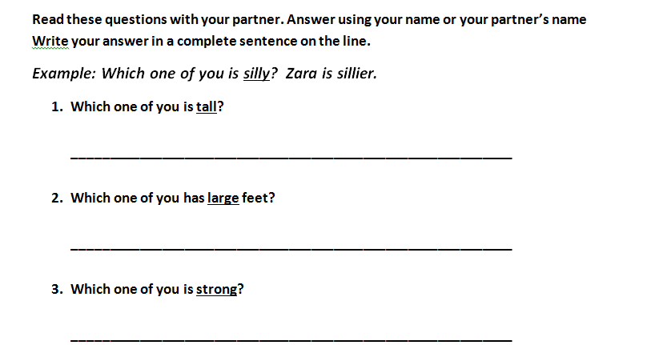  This is it, the heart of learning. Hands-on experiences are mandatory and should include chances for the studen  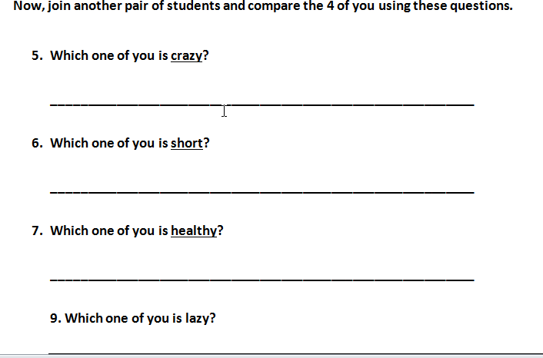  ts to collaborate and experiment and be able to discuss their learning with others. Provide specific details on the exploration activity in which your students will participate. Include hyperlinks or screen shots to videos, web resources, or mobile applications. Also, include any presentations or documents used. You are not required to use technology for the exploration phase but may choose to do so. | 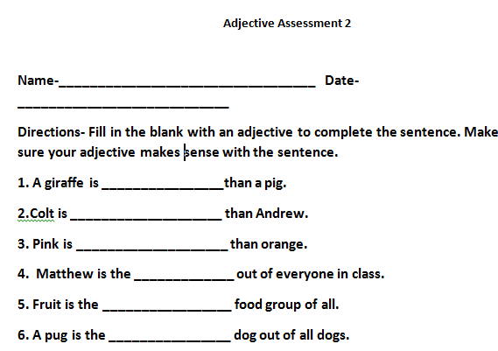  The assessment will be used to determine if students know how to compare nouns and selection the correct adjective.
Explanation | The teacher direct students to the words on the board.  Starting with the first column, the teacher will ask students what do all the adjectives have in common. ( “they all end with er”)  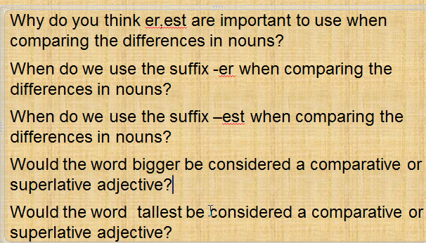  The teacher will ask students when they used the adjectives with er how many people were answering the questions. (“2 people were, me and my partner”)  The teacher will explain that when we compare the differences in two nouns we use comparative adjectives and comparative adjectives use the suffix –er at the end.  The teacher will direct students to the second column of adjectives on the board.  The teacher will ask students what do all the adjectives have in common. ( “they all end with est”)  The teacher will ask students when they used the adjectives with est how many people were answering the questions. ( “ 3 people were in our group, 4 people were in our group”)  The teacher will explain that when we compare the differences in three or more nouns we use superlative adjectives and superlative adjectives use the suffix –est at the end.  The teacher will explain when to change y to i and add a suffix to adjectives.  The teacher will clear up any misconceptions that the students may have.  The teacher will access students’ knowledge by asking the following questions:  Why do you think er,est are important to use when comparing the differences in nouns?  When do we use the suffix -er when comparing the differences in nouns?  When do we use the suffix –est when comparing the differences in nouns?  Would the word bigger be considered a comparative or superlative adjective?  Would the word tallest be considered a comparative or superlative adjective?  The students will write their answers on their personal white boards and raise their boards after each question.  The teacher will read a few answers out loud.  The teacher will clear up any misconceptions that the students may have. | The assessment will be used to determine if students understand the difference in comparative and superlative adjectives.
Elaboration | The teacher will explain to students that they are going to create a Kahoot game based on comparative and superlative adjectives.  The teacher will give an example of a Kahoot game that contains comparative and superlative adjectives.  The teacher will explain that all the questions must be related to comparative and superlative adjectives.  Some example of questions the students can ask are:  Which word is a comparative adjective, which word is a superlative adjective, what suffix is used at the end of a comparative adjective, what suffix is used at the end of a superlative adjective?  The teacher will emphasize that the students need to make sure they have the correct answers.  The groups will consist of 3 to 4 students.  Each group will meet and create 5 questions.  Once the group has written their questions, they can create their Kahoot game.  To view all the groups created Kahoots go to Kahoot.com  Username- briskey1920  Password- 123456  Group work sample  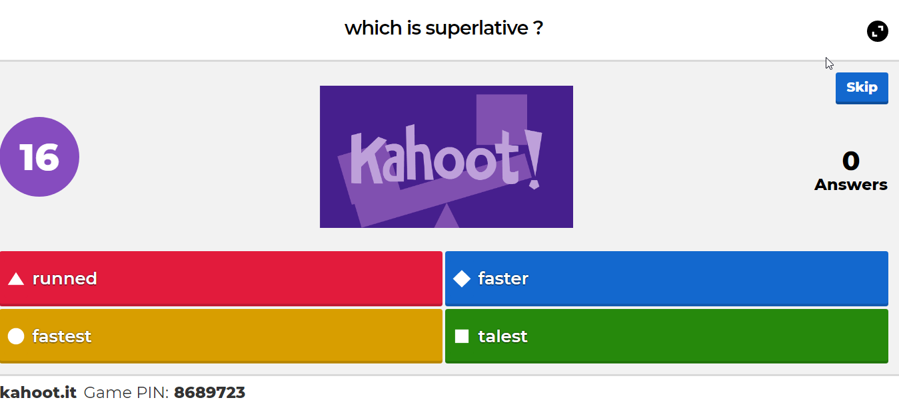  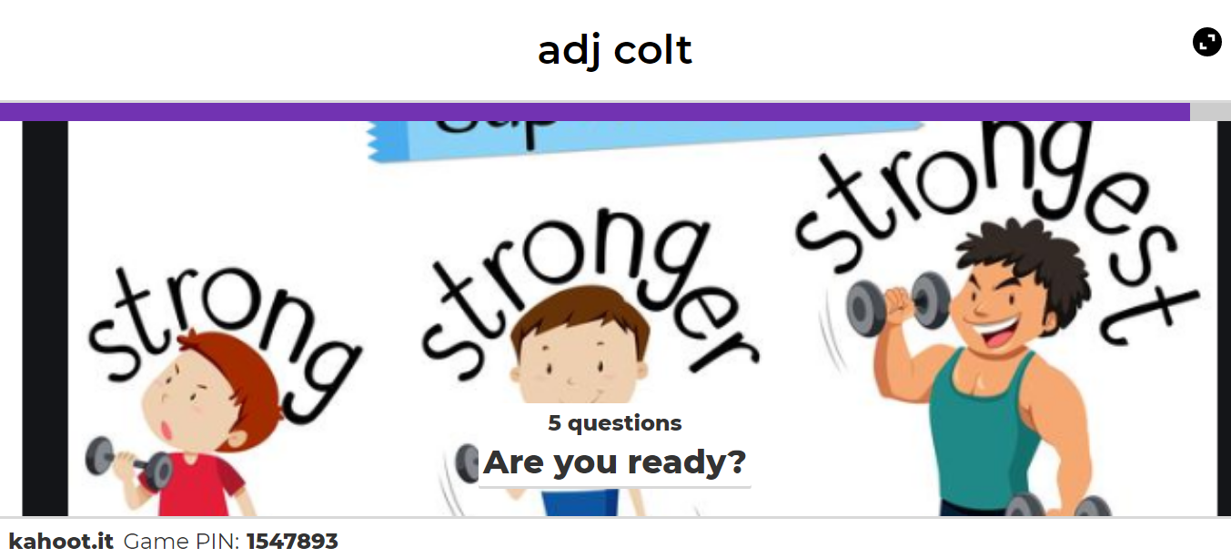 | The group’s ability to create questions with correct answers on their Kahoot game will be the assessment used for this phase.
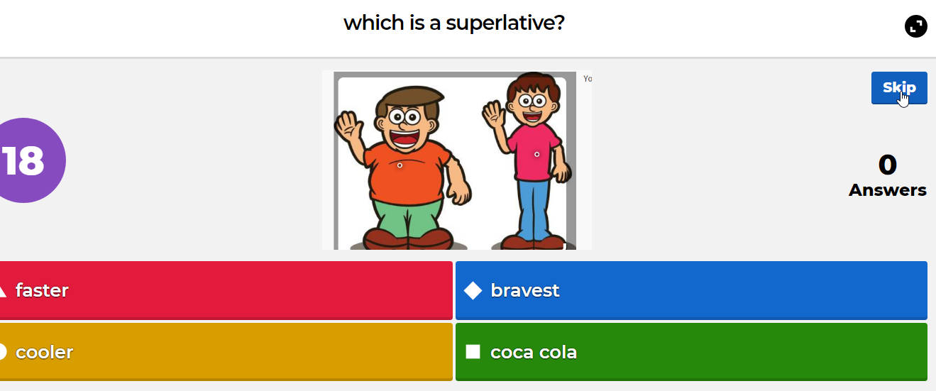
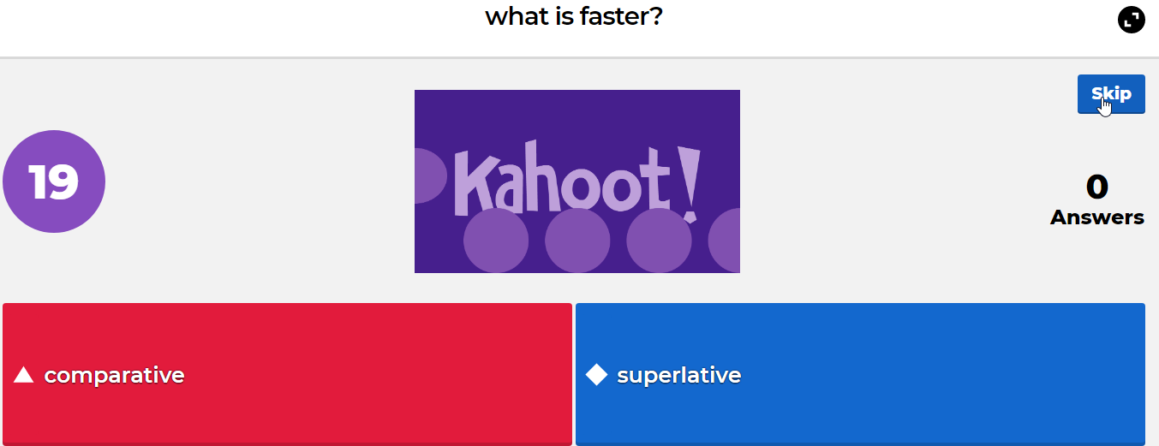

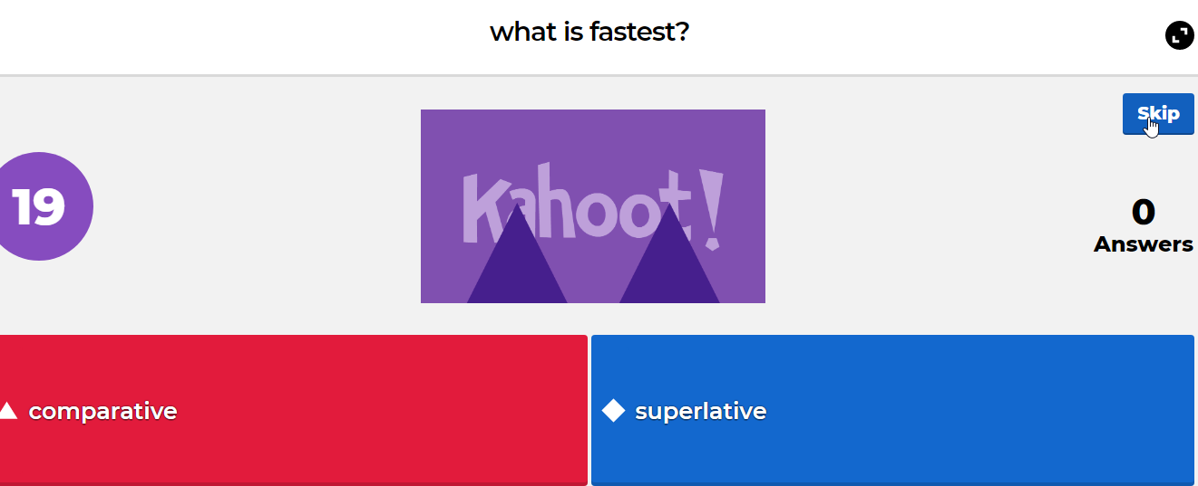
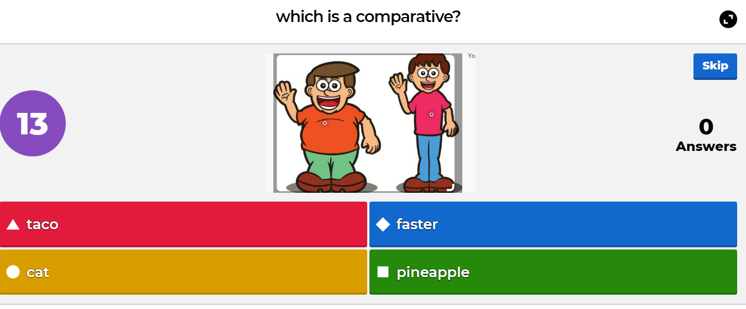

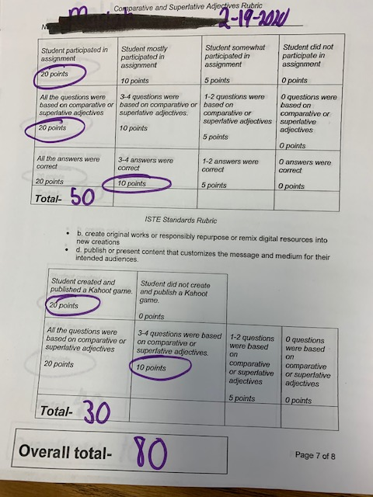  Evaluation | The teacher will evaluate each group and student’s Kahoot based on the criteria of the rubric. Students can receive up to 50 points based on their participation, if their questions were based on comparative and superlative adjectives.  Students could receive up to 40 points on the ISTE standards rubric. The points were based on if studentds help create and publish a Kahoot game, if the questions and answers were correct.  Below- Student graded rubric  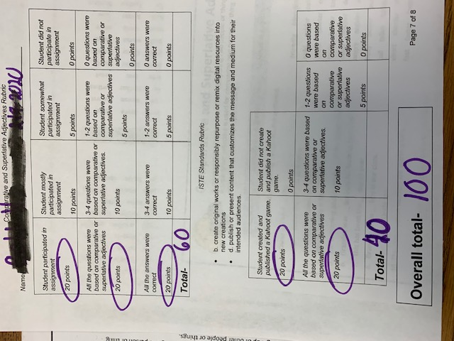

Comparative and Superlative Adjectives Rubric
Name-______________________________ Date:__________________________
Student participated in assignment  20 points | Student mostly participated in assignment  10 points | Student somewhat participated in assignment  5 points | Student did not participate in assignment  0 points
All the questions were based on comparative or superlative adjectives  20 points | 3-4 questions were based on comparative or superlative adjectives.  10 points | 1-2 questions were based on comparative or superlative adjectives  5 points | 0 questions were based on comparative or superlative adjectives  0 points
All the answers were correct  20 points | 3-4 answers were correct  10 points | 1-2 answers were correct  5 points | 0 answers were correct  0 points
Total-
ISTE Standards Rubric
- b. create original works or responsibly repurpose or remix digital resources into new creations
- d. publish or present content that customizes the message and medium for their intended audiences.
Student created and published a Kahoot game.  20 points | Student did not create and publish a Kahoot game.  0 points
All the questions were based on comparative or superlative adjectives  20 points | 3-4 questions were based on comparative or superlative adjectives.  10 points | 1-2 questions were based on comparative or superlative adjectives  5 points | 0 questions were based on comparative or superlative adjectives  0 points
Total-
Overall total-

